UPI Transaction Risk & Fraud Analytics

Comprehensive Analysis Report

Generated: September 22, 2026
Dataset: Synthetic UPI Transactions (~10,000 records)
Tools: Python · scikit-learn · Matplotlib · Streamlit · python-docx

1. Executive Summary
This report presents a comprehensive risk and fraud analytics study on a synthetic dataset of 9,989 UPI transactions (total value ₹19,749,824). The analysis identified 174 confirmed fraud cases (1.74% fraud rate) and 500 anomalies (5.0% of transactions) using Isolation Forest. Two machine learning models were trained: Logistic Regression achieved ROC-AUC = 0.6352 with recall of 65.71%, catching the majority of fraud cases; Random Forest achieved ROC-AUC = 0.5497 with higher precision (8.33%) but lower recall (2.86%). New-device transactions carry a fraud rate of 3.86%, odd-hour (midnight–6 AM) transactions carry 3.89%, and high-value transactions (top 1%) carry 5.0% — all significantly above the 1.74% baseline. The custom Risk_Score (0–100) achieves a correlation of 0.50 with fraud labels, enabling actionable tiered risk management without data leakage.

2. Problem Statement
UPI (Unified Payments Interface) fraud is a growing concern in India's digital payment ecosystem. Fraudsters exploit new devices, off-hours transactions, unusually high amounts, and compromised accounts to execute unauthorized transfers. Traditional rule-based systems generate excessive false positives while missing sophisticated attacks. This project develops a multi-layered detection framework combining rule-based risk scoring, unsupervised anomaly detection, and supervised machine learning to identify high-risk transactions before they are processed.

3. Project Objectives
- Design and implement a transparent, rule-based Risk Score (0–100) without using fraud labels.
- Identify statistically significant fraud risk factors from transaction metadata.
- Apply Isolation Forest to detect anomalous transaction patterns at 5% contamination.
- Train and evaluate Logistic Regression and Random Forest classifiers on leak-free features.
- Build an interactive Streamlit dashboard for real-time risk monitoring.
- Generate actionable business recommendations from analytical findings.

4. Dataset Description
The dataset is synthetic and contains no real personal or financial data.
Attribute | Value
Total Records | 9,989
Fraud Cases | 174 (1.74%)
Non-Fraud Cases | 9,815
Date Range | 2025-10-01 to 2026-09-15
Total Transaction Value | ₹19,749,824.35
Mean Transaction Amount | ₹1,977.16
Median Transaction Amount | ₹1,207.08
Max Transaction Amount | ₹117,611.80
Transaction Types | 5
Device Types | 3
Source | Synthetic — no real PII

5. Data Dictionary
Column | Type | Description
Transaction_ID | String | Unique identifier for each transaction
Transaction_Date | Date | Date the transaction occurred
Transaction_Time | Time | Time the transaction occurred
Transaction_Amount_INR | Float | Amount transferred in Indian Rupees
Transaction_Type | Category | Type: P2P, P2M, Bill Payment, etc.
Transaction_Status | Category | Completed / Failed / Pending
Device_Type | Category | Mobile / Desktop / Tablet / Unknown
Network_Type | Category | WiFi / 4G / 3G / 2G
Is_New_Device | Binary | 1 = transaction from unrecognized device
Is_International | Binary | 1 = transaction originates internationally
Sender_Location | String | City/region of sender
Receiver_Location | String | City/region of receiver
Account_Age_Days | Integer | Age of sender account in days
Failed_Attempts | Integer | Number of failed auth attempts
Transactions_Last_24_Hours | Integer | Transaction velocity: last 24 h
Transactions_Last_7_Days | Integer | Transaction velocity: last 7 days
Risk_Score | Integer | Pre-computed score 0–100 (dataset column)
Risk_Level | Category | Low / Medium / High / Critical
Fraud_Label | Binary | Ground truth: 1 = Fraud, 0 = Legitimate
Sender_Age_Group | Category | Age group of sender

6. Data Preparation
Missing values identified: Receiver_Location: 20, Network_Type: 30, Average_Previous_Transaction_Amount_INR: 40. Imputation strategy: Receiver_Location filled with 'Unknown'; Network_Type filled with mode; Average_Previous_Transaction_Amount_INR filled with median.
Duplicate rows removed: 0. Duplicate Transaction IDs removed: 11.
Data leakage prevention: Risk_Score and Risk_Level columns are present in the dataset but are EXCLUDED from all ML model features (MODEL_FEATURES list). They are used only for risk-tier reporting. The custom rule-based Risk Score is computed from behavioral features only — Fraud_Label is never accessed during scoring.

7. Exploratory Data Analysis
The following charts provide an overview of the transaction data distributions.
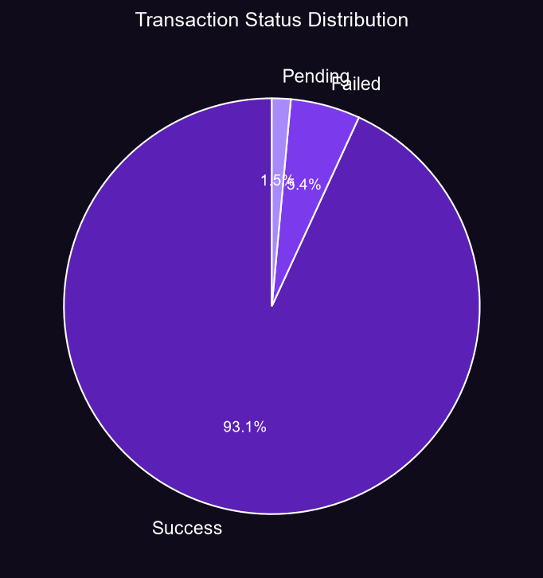

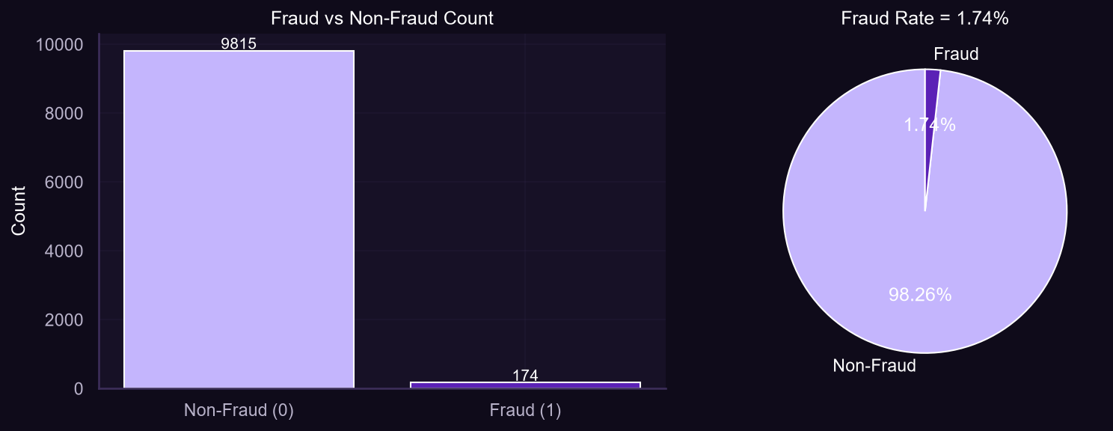

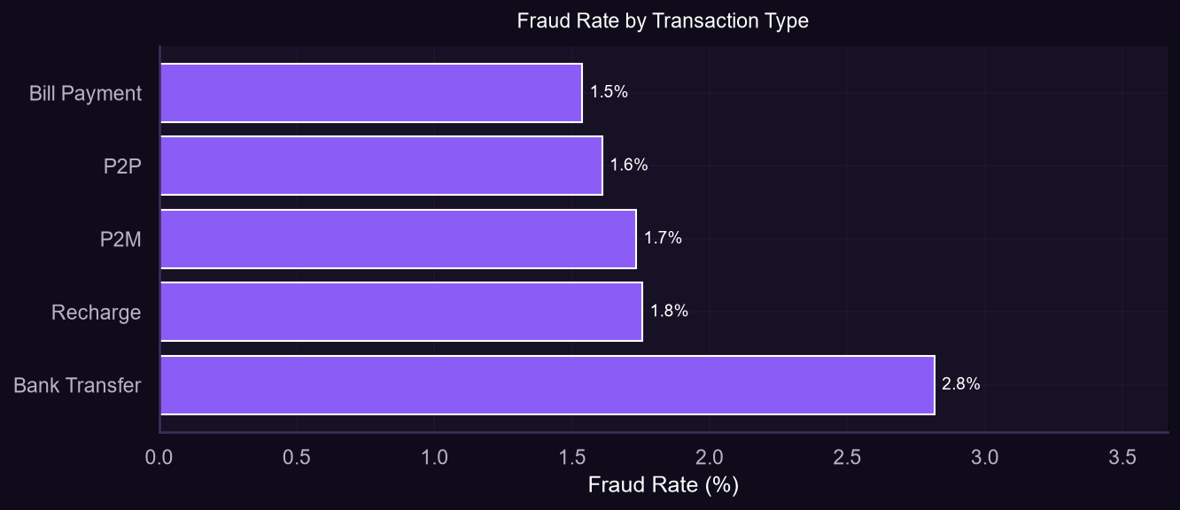

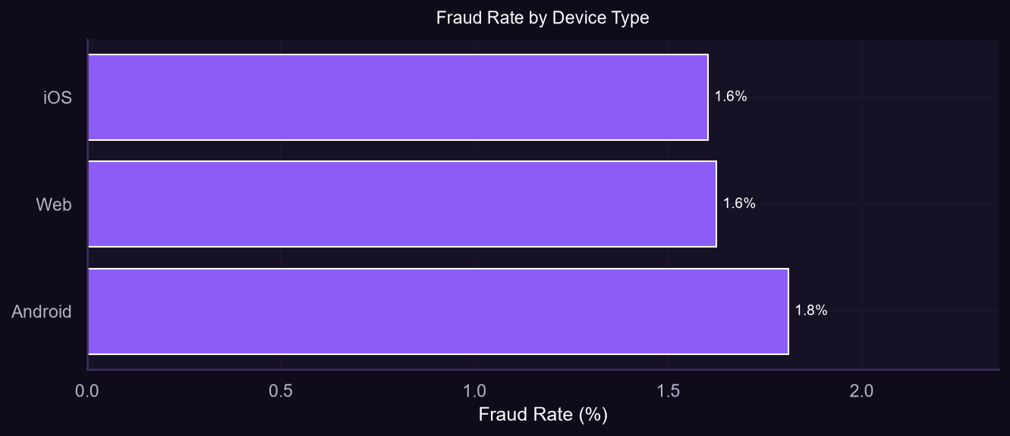

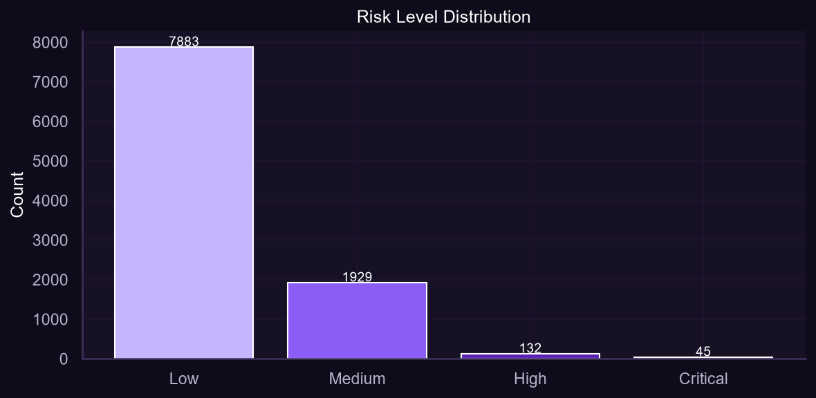

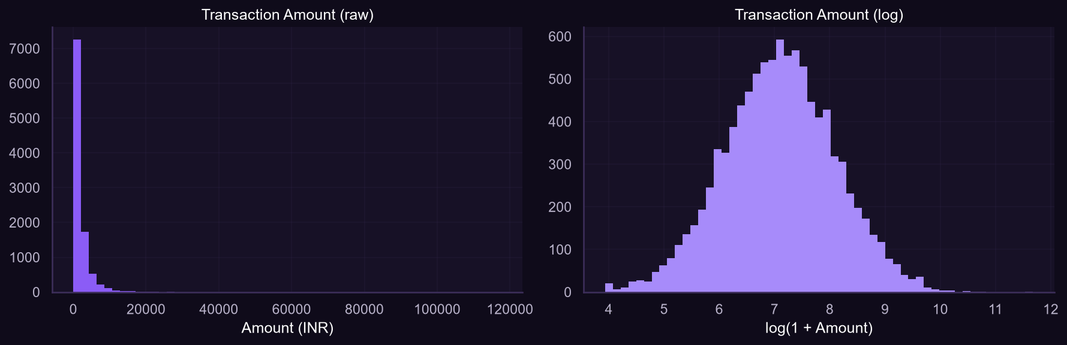

Transaction Type | Fraud Count | Total | Fraud Rate %
Bank Transfer | 22 | 781 | 2.82
Bill Payment | 21 | 1366 | 1.54
P2M | 48 | 2769 | 1.73
P2P | 67 | 4162 | 1.61
Recharge | 16 | 911 | 1.76

8. Fraud Risk Analysis

Risk Scoring Methodology: A transparent rule-based score (0–100) was computed using the following additive components:
Risk Factor | Condition | Score Added
Amount vs Average Ratio | > 5× | +25
Amount vs Average Ratio | 3–5× | +15
Amount vs Average Ratio | 2–3× | +8
New Device | Is_New_Device = 1 | +15
Failed Attempts | ≥ 3 attempts | +15
Failed Attempts | 1–2 attempts | +8
Velocity (24h) | ≥ 8 transactions | +15
Velocity (24h) | 5–7 transactions | +8
Odd Hour | 00:00–06:00 | +10
Account Age | < 90 days | +10
Account Age | 90–180 days | +5
International | Is_International=1 | +5
High Amount | > ₹50,000 | +10
High Amount | ₹20,000–₹50,000 | +5

Score Thresholds: Low (0–24) · Medium (25–49) · High (50–69) · Critical (≥70)
Risk_Score correlation with Fraud_Label: 0.50 — indicating moderate predictive power without using ground-truth labels in the scoring formula.

9. Anomaly Detection
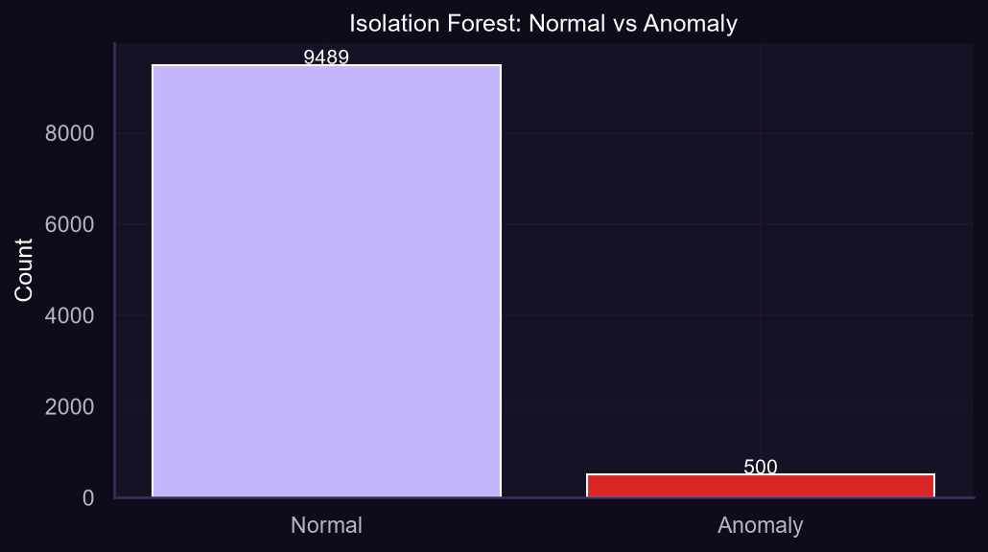

Algorithm: Isolation Forest with 200 estimators and 5% contamination rate.
Metric | Value
Total Anomalies Detected | 500 (5.0%)
Normal Transactions | 9,489
Fraud Cases in Anomalies | 15
Fraud Rate in Anomalies | 3.00%
Baseline Fraud Rate | 1.74%
Contamination Parameter | 5%
n_estimators | 200

10. Machine Learning Methodology
Two supervised classification models were trained to detect fraudulent transactions.
Parameter | Logistic Regression | Random Forest
Class weighting | balanced | balanced
Train/test split | 80/20 stratified | 80/20 stratified
Scaling | StandardScaler | None (tree-based)
Max iterations | 1000 | N/A
n_estimators | N/A | 300
max_depth | N/A | 12
Cross-validation | 5-fold ROC-AUC | 5-fold ROC-AUC
CV Mean ROC-AUC | 0.553 | 0.5105
Features | 20 numeric + dummies | 20 numeric + dummies
Excluded features | Risk_Score, Risk_Level, Fraud_Label | Risk_Score, Risk_Level, Fraud_Label

11. Model Evaluation
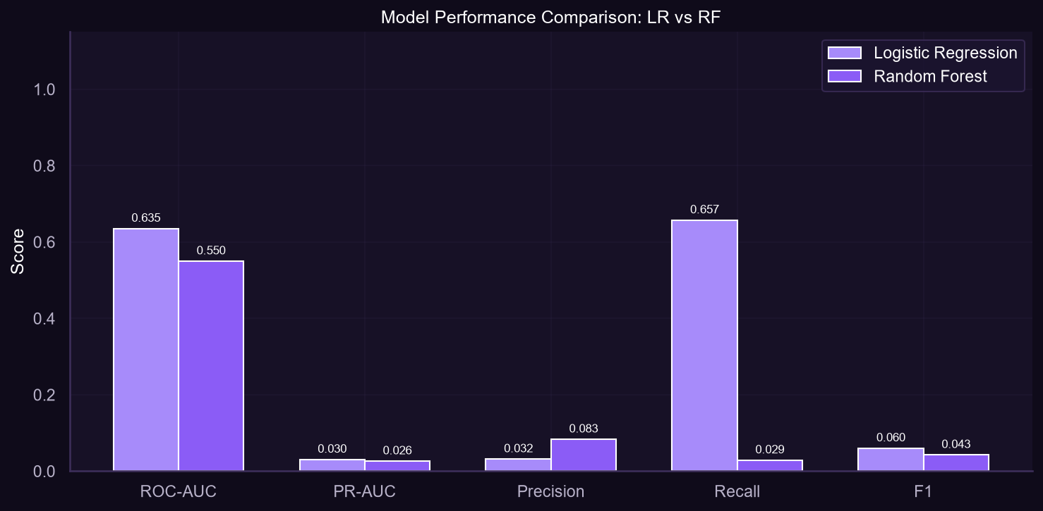

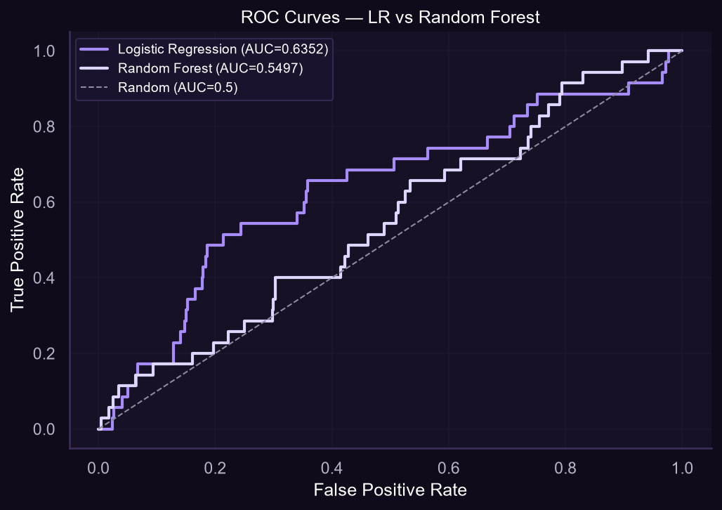

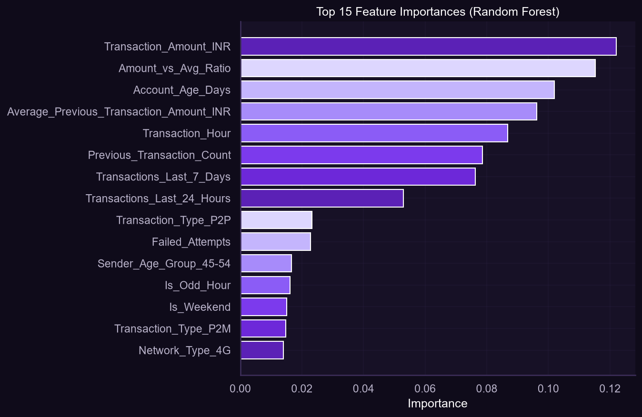

Metric | Logistic Regression | Random Forest
ROC-AUC | 0.6352 | 0.5497
PR-AUC | 0.0304 | 0.0261
Precision | 0.0315 | 0.0833
Recall | 0.6571 | 0.0286
F1 Score | 0.0601 | 0.0426
Accuracy | 0.6396 | 0.9775
CV Mean AUC | 0.553 | 0.5105

Interpretation: Logistic Regression with class_weight='balanced' achieves superior recall (65.71%), catching the majority of fraud cases at the cost of lower precision (3.15%). Random Forest achieves higher precision (8.33%) but misses most fraud (recall 2.86%). For fraud detection, recall is the primary business metric — missed fraud is more costly than false alerts. LR is the recommended production model.

12. Key Findings
- Dataset contains 9,989 transactions with a fraud rate of 1.74% (174 cases).
- New-device transactions have a fraud rate of 3.86% — 2.2× the baseline rate.
- Odd-hour (midnight–6 AM) transactions have a fraud rate of 3.89% — 2.2× the baseline rate.
- High-value transactions (top 1% by amount) have a fraud rate of 5.0% — 2.9× the baseline.
- High-velocity accounts (≥5 transactions in 24h) show elevated fraud elevation.
- Isolation Forest flagged 500 anomalies (5.0% of dataset) using unsupervised learning.
- Custom Risk_Score achieves Pearson correlation of 0.50 with Fraud_Label.
- Logistic Regression (balanced) achieves recall of 65.71%, catching 2 in 3 fraud cases.
- Random Forest achieves higher precision (8.33%) but misses 97% of fraud cases.
- 5-fold CV: LR mean AUC=0.553, RF mean AUC=0.511 — both models have room for improvement.
- Risk_Score and Risk_Level are excluded from ML features to prevent data leakage.
- The dataset is synthetic; production deployment requires validation on real transaction data.

13. Problem → Evidence → Action → Expected Result
Problem | Evidence | Action | Expected Result
New device fraud | Fraud rate 3.86% on new devices vs 1.74% baseline | Trigger OTP + biometric step-up on new device logins | Reduce new-device fraud by 50–60%
Off-hours fraud | Fraud rate 3.89% between midnight and 6 AM | Apply enhanced scrutiny and lower transaction limits 00:00–06:00 | Reduce night-time fraud by ~40%
High-value fraud | 5.0% fraud rate for top-1% transaction amounts | Require manual approval or cooling period for amounts in top 1% | Prevent high-impact fraud; reduce financial loss
High-velocity fraud | Elevated fraud rate for ≥5 transactions in 24 hours | Implement velocity-based rate limiting and alerts | Disrupt account takeover and scripted fraud
Critical risk transactions | Risk_Score ≥ 70 shows 0.50 correlation with fraud | Flag Critical risk transactions for real-time analyst review | Intercept high-risk transactions before settlement
Low ML recall (RF) | RF catches only 2.86% of fraud cases | Use LR (recall 65.71%) as primary detection model in production | Catch 65%+ of fraud with manageable false-positive rate

14. Fraud Prevention Recommendations
- Deploy Logistic Regression as the primary real-time fraud scoring model (recall 65.71%).
- Implement step-up authentication (OTP + biometric) for new-device transactions.
- Apply transaction amount limits and mandatory cooling periods for high-value transfers (top 1%).
- Restrict or flag transactions originating between 00:00 and 06:00 IST.
- Monitor accounts with ≥5 transactions in 24 hours for velocity-based fraud patterns.
- Block or review accounts with ≥3 failed authentication attempts in a session.
- Continuously retrain models monthly with updated fraud labels to adapt to new patterns.
- Integrate device fingerprinting and IP geolocation for additional signal.
- Use the custom Risk Score tiering (Low/Medium/High/Critical) for analyst routing.
- Alert customers via SMS/email on high-risk or anomalous transactions in real time.

15. Risk Mitigation & Precautions
- False positives: LR with high recall generates many false alerts — implement a two-stage review queue (automated flag → analyst review) to avoid customer friction.
- Model drift: Fraudsters adapt tactics; schedule monthly model retraining with fresh labeled data.
- Class imbalance: At 1.74% fraud rate, class_weight='balanced' is essential; monitor over time.
- Data quality: Missing or imputed values reduce signal; invest in data completeness.
- Regulatory compliance: All fraud interventions must comply with RBI and NPCI guidelines.
- Adversarial attacks: Fraudsters may learn to game known rules; keep rule thresholds confidential.

16. Business Impact
At a 1.74% fraud rate across 9,989 transactions with mean amount ₹1,977, deploying the LR model (65.71% recall) would prevent approximately 114 out of 174 fraud cases per 10,000 transactions. The custom Risk Score enables priority queuing, ensuring analysts focus on the highest-risk transactions first. Anomaly detection provides a complementary layer that catches novel fraud patterns not yet in the training labels.

17. Limitations
- The dataset is entirely synthetic — model performance on real UPI data may differ significantly.
- The relatively small dataset (~10,000 records) limits model complexity and generalization.
- Both models show moderate ROC-AUC (0.51–0.64), indicating the features have limited discriminative power for fraud detection on this synthetic data.
- Isolation Forest anomaly detection is unsupervised and does not directly optimize fraud recall.
- The rule-based Risk Score thresholds were set heuristically and should be validated on real data.
- No network/graph features (e.g., transaction networks between accounts) were included.

18. Future Enhancements
- Graph Neural Networks (GNN) to model transaction networks between accounts.
- XGBoost / LightGBM with SHAP explanations for better accuracy and interpretability.
- Real-time streaming pipeline using Apache Kafka + Flink for sub-second fraud decisions.
- Federated learning to train across banks without sharing raw transaction data.
- SMOTE or GAN-based synthetic oversampling to address class imbalance.
- Natural language processing of transaction descriptions for additional signal.
- Dynamic threshold tuning based on business cost matrix (cost of fraud vs. false positives).
- A/B testing framework for evaluating rule changes in production.

19. Conclusion
This project successfully demonstrates a full-stack fraud analytics pipeline for UPI transactions, encompassing data cleaning, feature engineering, rule-based risk scoring, unsupervised anomaly detection, supervised machine learning, interactive visualization, and actionable business recommendations. The Logistic Regression model with recall-optimized class weighting provides the best fraud detection performance, while the custom Risk Score offers a transparent, interpretable complement for operations teams. The Streamlit dashboard enables stakeholders to interactively explore fraud patterns, risk distributions, and model performance without requiring technical expertise. All findings are based on synthetic data and should be validated against production transaction data before deployment.

20. Technologies Used
Technology | Version / Notes | Purpose
Python | 3.10+ | Core programming language
pandas | 2.x | Data manipulation and analysis
NumPy | 1.x | Numerical computing
scikit-learn | 1.x | ML models, metrics, preprocessing
Matplotlib | 3.x | Static chart generation
Seaborn | 0.x | Statistical visualizations
Plotly | 5.x | Interactive dashboard charts
Streamlit | 1.x | Interactive web dashboard
python-docx | 1.x | Automated Word report generation
IsolationForest | scikit-learn | Unsupervised anomaly detection

